“We’ve Become A Voice”: The role of community led action in the 2019 Gospers Mountain bushfire
Emelia Merchant
Bachelor of Social Work Honours, The University of Sydney

Abstract
This article draws on thesis research to critically analysis top-down management of disasters that positions informal, localised responses as subordinate in relation to formalised disaster agencies (Darab, Hartman & Pittaway, 2020). This research project has focused on the specific experience of community residents recently impacted by the 2019 Gospers Mountain Fire in the Blue Mountains, New South Wales. It has utilised theoretical understandings of community development to promote the knowledge of ‘ordinary’ community perspectives often excluded in disaster management. It has identified taken for granted representation of community as ‘vulnerable’, ‘passive’ and ‘receivers’ of information. Rather it has found that post-fire the community has actively built social capital. Social networks strengthened and took on new meaning as the community continued to be active in disaster planning and recovery years after the disaster. Increased social capital also changed power relationships through increased community representation and the development of a ‘local voice’. Self-organised and informal groups became better able to identify and advocate for their interests and engage in democratic decision making. This research indicates the significance of localised, contextual knowledge and understanding in fire responses. It argues that this knowledge should be equally included in formalised disaster management and planning. This research hopes to facilitate structural change in disaster policy and practice through shifting hierarchical power relations in disaster responses.

Keywords
Disaster, Community Development, Social Capital, Knowledge, Power

Introduction
This research project has been conducted within the broader study documenting the lessons from Resilient Villages, a three-year pilot project which has been funded by the Federal Government’s Preparing Australian Communities Local Stream grant program (Resilient Villages, 2023). Resilient Villages is one of numerous projects in the Blue Mountains aiming to increase community led resilience to disasters following the devastation of the 2019-20 bushfires. Researchers from the University of Sydney have been involved in this project with the aim of developing a clear understanding of how best to support local, informal self-organising networks of community members in the context of increasing disasters due to climate change. The broader study implemented a methodological approach of Participatory Action Research (PAR) to ensure lessons were fed back directly into the activities of Resilient Villages, supporting change. Within this broader study, this research project has focused on the specific experience of community residents recently impacted by the 2019 Gospers Mountain Fire. This thesis provides a critical analysis of the top-down management of disasters positioning informal, localised responses as subordinate in relation to formalised disaster agencies (Darab, Hartman & Pittaway, 2020). This research hopes to facilitate structural change in disaster policy and practice through shifting hierarchical power relations in disaster responses.
The research has utilised theoretical understandings of community development to consider how to transform power relationships so that knowledge produced by disaster impacted communities is equally recognised in disaster management. Howard & Rawsthorne (2019) argue that shifting power is at the core of community development practice. PAR methodology is a good ‘fit’ for community development learnings as it supports the valuing of the knowledge produced by community residents (Rawsthorne et al, 2023).
The research question guiding this project asked; What were the experiences of community residents impacted by the 2019 Gospers Mountain Fire? Three findings were produced from the research. The first indicated that community residents are separated from and not included by formalised agencies and in New South Wales (NSW) state policy in regards to decision making processes. The second highlighted the active role of community led responses to the fire through increased social networks, challenging the assumption that communities are passive observers of disasters and less significant than formalised responses. The final finding highlighted the development of a local voice following the disaster, with aims of representing community interests and shifting hierarchical power relationships. Findings from this research will be used to discuss future implications for social work. It suggests that principles of community development and democratic decision making are central in promoting the knowledge and participation of community residents in Australian disaster management in policy, research and practice.

Literature Review
Epistemological Pluralism
Several scholars have identified increasing calls for epistemological pluralism and interdisciplinary collaboration in the conduct of disaster management and research (Spiekermann, et al., 2015; Andharia, 2020; Kwauk & Casey, 2022). Mainstream disaster research has historically been viewed through the lens of natural hazards, seen as a prime concern for physical sciences (Gaillard, 2021). Scientific knowledge has been assumed as the main source of credible knowledge in this disaster research space (Rawsthorne, Howard & Joseph, 2022; Spiekermann, et al., 2015). This has reflected a positivist scientific approach, assuming disaster management can be depoliticised and ‘managed’ through technocratic and scientific knowledge (Andharia, 2020). This has increased knowledge on predicting, monitoring and calculating the parameters and probability of extreme natural hazards (Galliard, 2021). However, this scientific dominance has been criticised for not engaging with the social impact of disasters which are increasing due to climate change (Spiekermann, et al., 2015). This piece of social work research is interested in filling this gap by looking at the institutional and structural power imbalances operating in disaster management.
Representations of Community and Knowledge Fragmentation
The dominance of a ‘hazard paradigm’ associates natural hazards as extreme, rare and exceeding people’s ability to respond or cope (Galliard, 2021). Common representations of disaster impacted places are as ‘un-informed’, ‘un-planned’, ‘un-prepared’, ‘over-populated’ and ‘under-developed’ (Galliard, 2021). As such ‘combat agencies’ have been positioned as best responders to these events (Joseph, Rawsthorne, Massola & Howard, 2023). Darab, Hartman & Pittaway (2020) indicate a hierarchical structure and professional expertise is embedded within formal emergency management systems. This is reflected in a commonly used command and control approach, implemented internationally by national governments and other formal organisations. This approach is founded in military theory and values hierarchical and top-down planning (Imperiale & Vanclay, 2019). Leadership is conceptualised as direction and control guided by a knowable future (Plowman et al., 2007).
Joseph, Rawsthorne, Massola & Howard (2023) and Andharia (2020) highlight policies and institutions create representations of community that shapes disaster responses. An analysis of NSW disaster policy highlighted the representation of disaster impacted communities as ‘vulnerable’ (Joseph, Rawsthorne, Massola & Howard, 2023). The labelling of people as ‘vulnerable’ has been criticised for misrepresenting people’s responses to disasters and leading to their stigmatisation as ‘helpless’ (Galliard, 2021). This representation has normalised increased paternalism, surveillance and governmentality from formalised disaster agencies (Rawsthorne, Howard & Joseph, 2022). Galliard (2021) challenges this by highlighting the resilience and capacity of disaster impacted citizens, who are often the first responders to disasters. However, policy continues to divide the response and role of community in disaster management as separate and distinct from formal systems (Joseph, Rawsthorne, Massola & Howard, 2023). Knowledge production in disaster policy and practice continues to differentiate between formal disaster agencies and responders, and informal, community led responses (Joseph, Rawsthorne, Massola & Howard, 2023).
Community Participation
The increasing frequency and severity of disaster events has raised questions about the effectiveness of ‘combat agencies’ in disaster preparation and prevention (Rawsthorne, Howard & Joseph, 2022). This has contributed to calls for increased community participation in disaster management (Rawsthorne, Howard & Joseph, 2022; Webber, Gissing, Duffy & Bird; 2017). When discussing community participation Webber, Gissing, Duffy & Bird (2017) challenge emergency planning that views community residents as ‘spectators’ and not as active participants in decision-making. These scholars highlight the traditional one-way communication approach that ‘educates’ and ‘informs’ communities in a top-down relationship (Webber, Gissing, Duffy & Bird; 2017). This is challenged for overlooking the complexity of rural and regional community members who are involved in both systems of emergency management (Joseph, Rawsthorne, Massola & Howard, 2023). Galliard (2021) challenges the dismissal of community knowledge through considering how self-organising systems become active in disaster responses, unsettling dominant understandings of community as passive. This is discussed by Comfort (1994) through the concept of self-organisation, which refers to ways local citizens participate in their survival, separate to an external authority. Self-organisation is characterised by adaptively and responsiveness to a complex and changing environment, rather than a plan based on knowable outcomes (Comfort, 1994). Jewkes & Murcott (1998) suggest community participation requires changing how informal groups are conceptualised, so they are valued in their own right.
Theoretical Framework
This research has been framed by theoretical understandings of community development. Community development is a process of inclusive and participative action developing local skills, resources, assets and capacity (Cavaye & Ross, 2019). Principles of inclusion and participation de-stabilises hierarchical power structures as they value the contribution of knowledge from marginalised groups (Darab, Hartman & Pittaway, 2020). This theoretical framework reflects epistemological value for knowledge produced by ‘ordinary’ perspectives and experiences of disaster survivors (Briones, Vachon & Glantz, 2019). Power is central when considering everyday practice with community, and attention should centre on shifting power from those with privilege (Howard & Rawsthorne, 2019).
Michel Foucault’s analysis of structural relationships of power is a secondary theoretical approach used in this research, complementing the broader community development framework. Foucault suggests that power relations operate within a social nexus, guiding possibilities of conduct and action within power relationships (Foucault, 1982). Power relations can determine the conduct and actions of others, establishing the field of possibilities in which one can act (Foucualt, 1982). Power relations shape what knowledge is privileged (Foucault, 1982). Opposing the effects of power involves challenging the privileging of knowledge, and representations imposed on groups that are taken for granted (Foucault, 1982). This aligns with the praxis of critical pedagogy in community development (Ledwith, 2016). Ledwith (2016) suggests Paulo Freire’s understanding of critical pedagogy provides the theory and conceptual tools to be integrated in community development practice, in which theory is applied in action which in turn develops theory (Ledwith, 2016). Conscientisation is central to Friere’s critical pedagogy, in which people interrupt and question the links between knowledge and power in everyday life often taken for granted (Ledwith, 2016). Change is enabled through learning and education based in critical consciousness, particularly through increasing individual and group knowledge of political systems (Howard & Rawsthorne, 2019; Ledwith, 2016). This involves an understanding that education is not neutral, rather it can reinforce structures of social inequality or it can involve exposing, questioning and changing these structures to support justice, fairness and sustainability (Ledwith, 2016).
Pierre Bourdieu’s concept of social capital was also applied in the research (Bourdieu, 1986). Social capital refers to the potential or actual resources made available through membership in a group (Bourdieu, 1986). The size of the network of connections and volume of capital within those connections correlates to the volume of social capital (Bourdieu, 1986). A group is continuously re-produced through symbolic or material exchanges. Mutual recognition of the meaning within exchanges reproduces the group and simultaneously establishes limits of the group (Bourdieu, 1986). Following a disaster, usual resources such as temporary living accommodation, childcare, petrol or food are shut down (Aldrich, 2017). In this time, local survivors may use resources offered through informal avenues such as friends or neighbours. This suggests strong social networks enable exchanges of mutual aid and informal insurance following a disaster (Aldrich, 2017). The concept applies to community developments aims of supporting community leadership (Howard & Rawsthorne, 2019). Community leadership departs from typical understanding of hierarchical and individualised leadership. In everyday community practice supporting community leadership means building relationships and networks to bring people together to work towards a common purpose in a community or place of interest. The common purpose is always related to community benefit (Howard & Rawsthorne, 2019). Aldrich (2017) suggests social capital is central in building community resilience to disasters (Aldrich, 2017). Aldrich indicates that many challenges that individuals experience in the aftermath of a disaster are collective action challenges (Aldrich, 2017). Communities in which residents scarcely work together may have trouble voicing their needs to recourse providers, or to promote an agreed upon vision for the future (Aldrich, 2017). Alternatively, communities in which residents work together in terms of their recovery and share a collective identify demonstrate increased resilience (Aldrich, 2017).

Methodology
Participatory Action Research (PAR) is the research methodology utilised in this research, enabling researchers to work with communities in partnership in a way that generates action for change (Baum, MacDougall & Smith, 2006). PAR recognises that the decisions and action-effects of research are value driven and views the researcher as a facilitator of a group’s pursuit of their inquiries, to obtain their truth (Wadsworth, 1998). In this way PAR is a significant epistemological challenge to conventional or positivist social science which assumes there is an objective reality which can be discovered by an objective and independent researcher (Wadsworth, 1998). Power is a foundational concept to PAR, with aims of shifting power relations and difficulties in accessing resources (Baum, MacGougall & Smith, 2006). PAR developed as a way of questioning the nature of knowledge and the way knowledge can reflect the interests of the powerful and is used to maintain their social positioning (Baum, MacDougall & Smith, 2006). PAR is routinely used in community development practice due to its focus on participation, collaboration and change.

Method
A mixed-method approach was used in this study. Data was triangulated, drawing on qualitative interviews, quantitative survey responses and the researcher’s own ethnographic observations through the collection of visual images (O’Reilly, 2004). This mixed methods approach engages with a diversity of perspectives and knowledge is produced through participation of both the community and researchers.
The researcher participated in the collection of quantitative survey data at the 2023 Autumn Lyrebird Markets. This makers and growers market was organised by the Association of Bell, Clarence and Dargan (ABCD) as an initiative to support locals through their ongoing bushfire recovery. The surveys were intended to generate feedback that could be used by the Association to inform future markets. The survey design and questions were co-developed by university academics and community leaders, reflecting a commitment to participation and producing knowledge that combines community and professional perspectives (Baum, MacGougall & Smith, 2006). There were 54 responses to the survey on the day, with the majority of participants being from the Blue Mountains and more than half being from Bell, Clarence and Dargan. Data from the survey was put through the statistical analysis software called SPSS statistics.
Visual forms of data were collected parallel to conducting surveys as a method of ethnographic observation. This method involves the analysis and interpretation of visual data that has been produced by community residents involved in the organisation of the market (O’Reilly, 2004). These images can explore community perspectives as expressed through the things they produce, however, acknowledge the active role of the researcher in interpreting meaning from the image (O’Reilly, 2004).

Four interviews were included in the data set to engage with the knowledge and subjective experience of a diversity of community members impacted by the 2019 Gospers Mountain Fire. Interviews were recorded and transcribed and then coded following a guide produced by Braun & Clarke (2006). Two of the participants were residents of Clarence, one of Dargan and the other Mount Tomah. The limitation of this method is the small sample size, with the intention of this study not to generalise findings to represent the entire community.
Thematic analysis was implemented to identify, analyse and present patterns or themes within data in the attempt to theorise their significance and broader meaning (Braun & Clarke, 2006). Themes were identified following a theoretical thematic analysis over an inductive approach given the scope of the research project (Braun & Clarke, 2006). This recognised the theoretical framework of community development in shaping analysis and selection of themes (Braun & Clarke, 2006). Themes were identified at a latent level over a semantic level, to identify and examine the underpinning assumptions, conceptualisations and ideas of community in disaster management and responses (Braun & Clarke, 2006). Through repeated reading and engagement with the interview transcripts, survey findings and ethnographic observations the researcher actively searched for patterns and meaning across the entire data set. Selected themes were then related back to the literature, theoretical framework and research question as a form of critical analysis, presented in the discussion section (Braun & Clarke, 2006).
Research findings
- Decision making process
Participants experienced fire response plans being enforced by command structures external to the local area that didn’t liaise with residents. Participant 2 describes decisions being made for Mount Tomah by two command structures both 80 kilometres away, which lacked knowledge of local environments and locations, leading to poor coordination;
So people are sent out to do work in places they have no understanding of and would have found absolutely terrifying, whereas the locals would have understood it better and known what’s going to be okay and what’s not. They were not listened to. (Participant 2)
Participant 2 describes a back burn being lit in the surrounding Mount Tomah area by a Rural Fire Service (RFS) unit not from the community. The local RFS had advised against the back burn being lit based on their knowledge of the terrain and weather conditions of the day. This back burn then took over the Gospers Fire as a major fire. Having not been informed of the back burn or the increased fire danger, participant 2 experienced complications in his and his wife’s evacuation.
We were out of the loop, something had gone wrong and we were in imminent danger. Now, the reason I say that is because these spiral roads, it’s arb roads, you can get trapped on them. (Participant 2)
Participants were excluded from providing their feedback or having their experience recognised in official documentation. In this way, their experience is excluded from future planning and decision making. Participant 2 had prepared her property extensively prior to the Gospers Fire, and had evacuated prior to the fire with her daughter. She felt that Dargan had not been recognised in media documentation and had been ignored by formal service responses, reflected in lack of government funding;
We weren’t Mallacoota with people sheltering on a beach and those evocative images going out onto the news…Therefore it didn’t happen at our place and that has been the feeling right throughout, is that we are ignored, forgotten. We don’t get bushfire funding money. We don’t even get mentioned in the bushfire books. (Participant 1)
Participant 3 described herself as representing a community perspective whilst being on the local RFS unit. This is because local RFS units are comprised largely from local volunteer community members. This reflects local community residents who navigate both the formal and informal service system. Participant 3 suggested that anger directed at on the ground emergency responders including the Australian Defence Force was mid-directed;
These guys are following orders, they don’t have answers for anyone, they’re just doing what they get told. That’s the nature of being in the army, so not unlike us being in the RFS we just go and do what we’re told. (Participant 3)
Survey data produced at the markets draws attention to how local community residents of Clarence, Dargan and Bell interact with current disaster management policy operating in NSW. Policy is framed by the State Emergency and Rescue Management (SERM) Act 1989, informing the NSW State Emergency Management Plan (EMPLAN) (2018a) and Emergency Risk Management Framework (2017). This policy outlines the structure of Local and Regional Emergency Management Committees (LEMCs). LEMCs create Local Emergency Management Plans, which is intended to address emergency management in phases such as prevention, preparedness, response and recovery (Joseph, Rawsthorne, Massola & Howard, 2023). Figure 1 indicates that 16% of residents knew about the Local Emergency Management Plan for the area, 31% were somewhat familiar and a little more than 50% we’re not familiar with the plan. This indicates that a majority of community residents are not familiar with the formalised disaster management plan for the area.
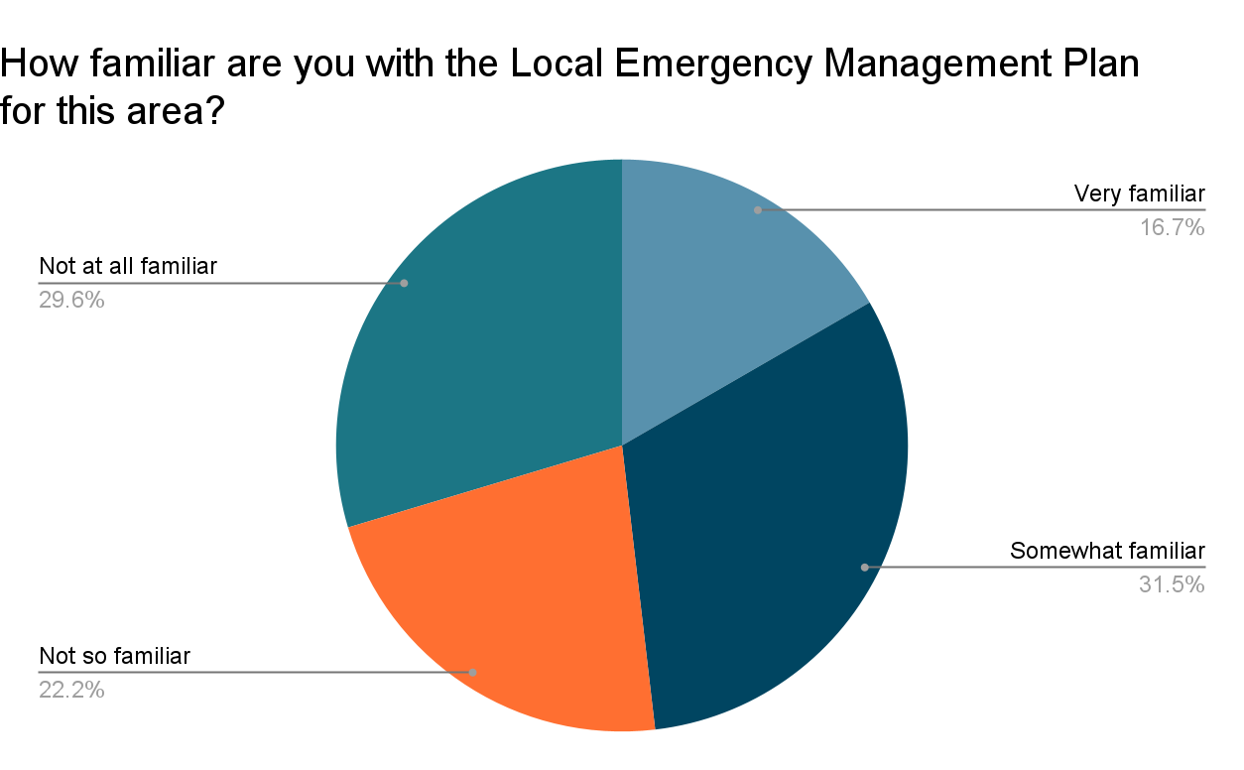
Figure 1. Survey Findings on LEMP (Merchant, 2023)

- Community Led Recovery and Preparedness
The second theme focuses on community led recovery and preparedness. Participants were highly active in their survival, taking actions to protect their families and neighbours. Participant 4 described spending 6 hours putting out fires on her property together with her neighbour. Here she highlights the importance of local people working together to help their neighbours.
We were fighting the fire and then two or three doors down, his place must have been okay and he got in his truck and was going around helping people put fires out. (Participant 4)
Participant 2 describes the significance and meaning of social networks and of community following the fire.
It was really interesting to see people switch from just being someone who lives next door to you, to somebody that you need. Suddenly the place you lived in amplified. (Participant 2)
Participants were highly involved in post-disaster processes long after formal services left the area. All participants spoke about the ongoing impact of the fire, as years later some residents didn’t have permanent housing, continued to be financially impacted by the disaster, and their mental health is impacted. Participants discussed recovery taking a long time and funding stopping prematurely.
There’s a lot of activity at the beginning of a disaster. A lot of activity, A lot of focus on contacting people and providing support, but then it dies away and everybody's energy and goodwill and everything kind of goes away to the next thing. (Participant 3)
Figure 2 is a photo of a poster taken at the market produced by the Association of Bell, Clarence and Dargan. It shows that 4 years on from the fire, the local community continues to be active in fire responses. It indicates the central role of community led response after the departure of formal services.
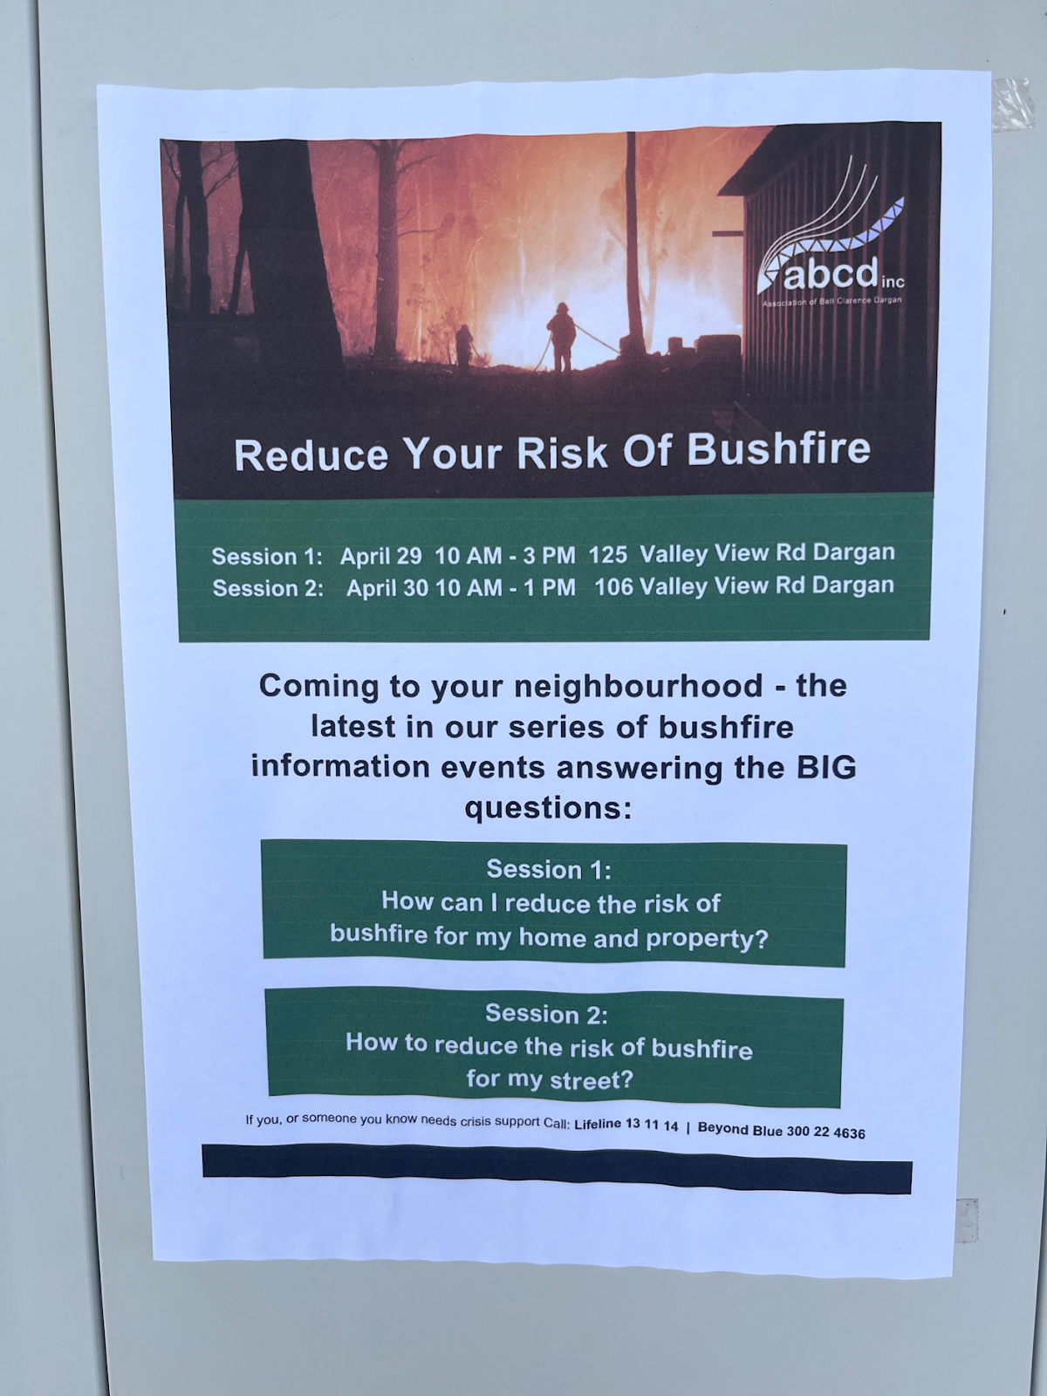
Figure 2. ABCD produced poster on fire preparation (Merchant, 2023)
Findings indicated that social networks strengthened following the disaster, which led to the establishment of community-led groups, composed of various members of the community. Collectively, people became more reflective and critical of what was occurring.
“We were all just individual bushfire victims, sitting there thinking that somebody was going to help us and they weren’t. After not getting anywhere. We’ve formed our own community association up at Clarence…We are a community-led recovery group. We have formed because of the fire, but we want to be more than that. We want to be sustainable into the future” (Participant 1)
The group identified that there was an unequal distribution of support from formal services, with not all members in the community being accessed. The community led association established its own list of residents and identified how to disseminate information effectively in the local context, particularly to people not on social media, email or who had their letterbox burnt down. Figure 3 indicates the diversity of ways people in this community access information, including through direct social networks and word of mouth, as well as ABCD led communications.
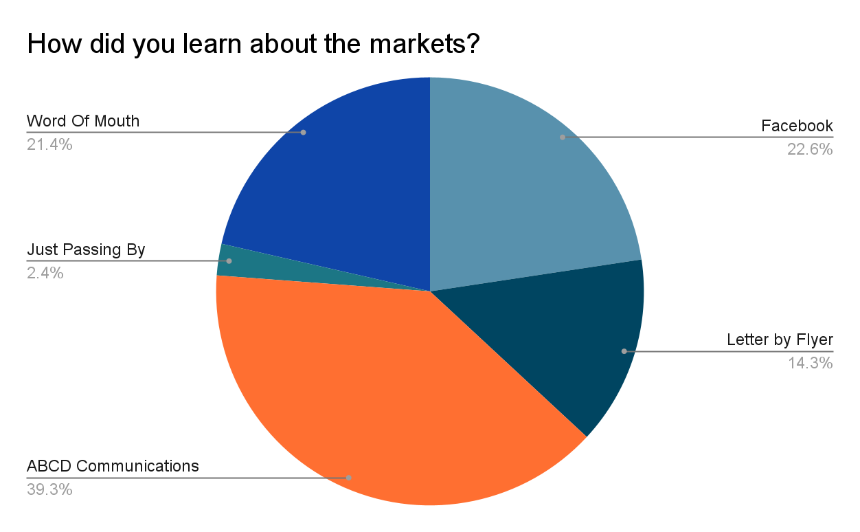
Figure 3. Survey data on how residents learnt about the market (Merchant, 2023)
The need for a collective response that engages with a diversity of community members, including people not in formal services is highlighted.
Putting a street coordinator say so that when an event’s coming that person can then go around and letter box drop, or find who’s home, who’s not home, are they on holidays, all those sorts of things…
It’s not like one person in the brigade trying to get everybody in the community, you’ve got a few people in each street that can (Participant 3)
- A Local Voice
The strengthening of social networks has led to the development of community associations that have become informal representatives of the community promoting local needs to formal services. Participant 2 highlights establishing these groups has increased dialogue with the government.
We’ve been learning about how these things work, so when the big questions are asked and the minister says, “I need an answer now about what people there want” they don’t go and do a survey of what the neighbourhood, they go to somebody who’s got a voice, who’s got an agency. That was our goal. We’ve done really, really well at that. (Participant 2)
Figure 4 shows a map produced by ABCD. Here the community is representing their own experience. This question, “Where were you on December 21 2019?” promotes participation from local residents. It validates that their experience of the fire is worth talking about. It is engaging with those perspectives which are often not heard.

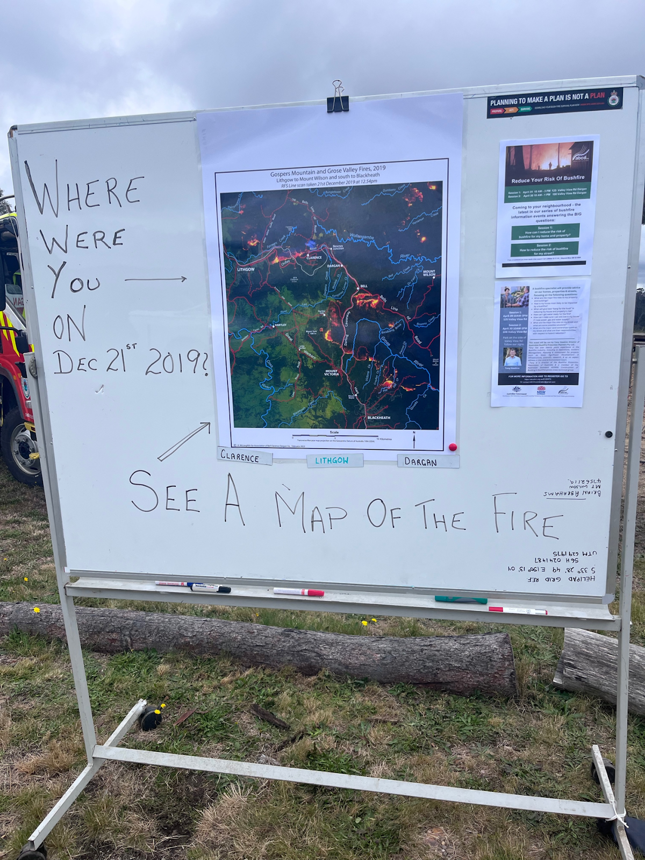
Figure 4. ABCD produced map at the market (Merchant, 2023)
Participant 1 explains how ABCD led initiatives promote local ownership and recognition. For example, the community is better able to apply for funding and grants that they identify as useful, rather than as decided from an external community agency.

Its our focal point when we come together. ABCD, this is our tent, and artwork on the side that at an event, we actually get our community to come up and be part of decorating the tent…It sounds frivolous but it’s an important way of people owning it and being part of it and so that was part of the grant. (Participant 1)
The importance of local knowledge was signified by participant support of the local community newsletter (the Lyrebird Local). The Lyrebird Local is produced by the Association for the Bell, Clarence and Dargan community. Half of all survey participants read the Lyrebird local. Survey data indicated 33.3% of the participants who read the newsletter specifically liked that it produced local stories and content and 8.3% liked it for keeping them informed about the community. The newsletter frequently publishes content of local stories and experiences of the fires, information on local nature and wild-life, as well as current fire preparedness workshops or community based initiatives, such as the establishment of a new community hall. This signifies the importance of a collective local identify, represented through the stories in the local publication.

Discussion
This research was framed by the research question: What were the experiences of community residents impacted by the 2019 Gospers Mountain Fire? Data from the mixed method study provides important insights for future action and policy change. Data highlighted the resident’s experiences of a command and control response from formal services, both in practice and in policy. This approach valued hierarchical and top down planning, valuing professional and expert knowledge, at the exclusion of knowledge from residents and communities. Literature indicates that disaster affected citizens are often presented as victims who passively wait for assistance (Briones, Vachon & Glantz, 2019). Communities are thought of as unable to participate in their recovery. Linking back to Foucault’s structural understandings of power, the findings demonstrate that opportunities to participate in decision making and disaster preparation operate within these taken for granted representations that produce a power imbalance. This was reflected in participants not being informed about decisions of back burning in the local area or local RFS units being ignored in decision making processes. In practice, formal command centres and RFS units did not involve or liaise with community residents in their fire management decisions. This limited the field of opportunities in which community residents could choose to prepare and fight the fire or prepare to evacuate with enough time. This is further evident in legislation such as the local emergency management plan that is not intended to be viewed by the public, its audience is other formal service stakeholders (Joseph, Rawsthorne, Massola & Howard, 2023). These plans are not developed with communities recognising their perspective and knowledge.
Focusing on the experiences of disaster impacted communities challenges these taken for granted representations applied to communities. Findings indicated that ‘ordinary’ community residents had high levels of knowledge in disaster preparation and planning. The increase of social capital is reflective of the community’s active participation in recovery, planning and wellbeing into the future. The networks between community members was central in the immediate response to the fire, as neighbours relied on each other through exchanges of aid, support and material resources. The collective experience of the fire produced a mutual recognition between community members, and established a local group or ‘voice’. Collectively community residents through associations could promote their interests, representing their localised, contextual knowledge of the area. Ongoing activity enabled through strong social networks has been to the communities benefit, through its focus on disaster response and preparation. Participants reflected on the changed significance of social networks in the event of the disaster and in the ongoing response as the meaning of place and community increased. Communities were highly active in their own survival in the immediate response to the fire as well as long after formal services had left. The ongoing response and fire recovery was collective, evident in the development of community led associations that promoted and represented a community voice. Participants described increased knowledge of the surrounding formal response through connecting with other community residents. Through collective learning and education, they recognised this was more than an individual issue, rather it is located within broader political systems. This supports community developments understanding of leadership, as supported through building of relationships, and not one individual leader. People were brought together to work towards a common purpose in the community’s interest (Howard & Rawsthorne, 2019).

Conclusion
This research has utilised theoretical understandings of community development to promote the knowledge of ‘ordinary’ community perspectives often excluded in disaster management. It has identified taken for granted representation of community as ‘vulnerable’, ‘passive’ and ‘receivers’ of information. It has identified the limitations of these representations in providing a coordinated response. This research has challenged this representation by acknowledging the active role of community. This is particularly evident in the increase of social capital following the fire. Social networks strengthened and took on new meaning as the community continued to be active in disaster planning and recovery years after the disaster. Increased social capital also changed power relationships through increased community representation and the development of a ‘local voice’. Self-organised and informal groups became better able to identify and advocate for their interests and engage in democratic decision making. This research indicates the significance of localised, contextual knowledge and understanding in fire responses. It argues that this knowledge should be equally included in formalised disaster management and planning.

References
Andharia, J. (2020). Thinking about disasters: A call for intersectionality and transdisciplinarity in disaster studies. In Disaster Studies (pp. 3–32). Springer Singapore Pte. Limited.
Aldrich, D.P. (2017). The Importance of social capital in building community resilience. In W.Yan & W. Galloway (Eds.), Rethinking Resilience, Adaptation and Transformation in a Time of Change (pp. 357-364). Springer International Publishing.
Briones, F., Vachon, R., & Glantz, M. (2019). Local responses to disasters: Recent lessons from zero-order responders. Disaster Prevention and Management, 28(1), 119–125.
Braun, V., & Clarke, V. (2006). Using thematic analysis in psychology. Qualitative Research in Psychology, 3(2), 77–101.
Baum, F., MacDougall, C., & Smith, D. (2006). Participatory action research. Journal of Epidemiology and Community Health (1979), 60(10), 854–857.
Bourdieu, P. (1986). The forms of capital. In J.G. Richardson (Eds.), Handbook of Theory and Research for the Sociology of Education (pp. 241-258). Greenwood Press.
Cavaye, J., & Ross, H. (2019). Community resilience and community development: What mutual opportunities arise from interactions between the two concepts? Community Development (Columbus, Ohio), 50(2), 181–200.
Comfort, L. K. (1994). Self-organisation in complex systems. Journal of Public Administration Research and Theory, 4(3), 393-410.
Darab, S., Hartman, Y., & Pittaway, E. E. (2020). Building community resilience: Lessons from flood-affected residents in a regional Australian town. International Journal of Community and Social Development, 2(4), 409–425.
Foucault, M. (1982). Afterword. In H.L., Dreyfus., & P. Rabinow (Eds.), Michel Foucault: Beyond Structuralism and Hermeneutics (1st ed.) (pp. 208-226). Routledge.
Gaillard, J. C. (2021). A genealogy of disaster studies. In The Invention of Disaster: Power and Knowledge in Discourses on Hazard and Vulnerability. (pp. 27-42). Routledge.
Howard, A., Rawsthorne, M., Joseph, P., Terare, M., Sampson, D., & Katrak, M. (2023). Social Work and human services responsibilities in a time of climate change: Country, community and complexity. Routledge, Taylor & Francis Group.
Howard, A., & Rawsthorne, M. (2019). Everyday community practice. Allen & Unwin.
Imperiale, A. J., & Vanclay, F. (2019). Command-and-control, emergency powers, and the failure to observe United Nations disaster management principles following the 2009 L’Aquila earthquake. International Journal of Disaster Risk Reduction, 36, 1-14.
Joseph, P., Rawsthorne, M., Massola, C. and Howard, A. (2023). Shared responsibility and community engagement in local emergency management policy: What’s the problem represented to be?, University of Sydney.
Jewkes, R., & Murcott, A. (1998). Community representatives: Representing the “community”? Social Science & Medicine (1982), 46(7), 843–858.
Kwauk, C. T., & Casey, O. M. (2022). A green skills framework for climate action, gender empowerment, and climate justice. Development Policy Review, 40(2), 1-19.
Ledwith, M. (2016). Paulo Freire’s critical pedagogy. In Ledwith, M & Freire (Eds.), N. Community development in action: Putting Freire into practice (1st ed., pp. 21–40). Bristol University Press.
O’Reilly, K. (2004). Visual data and other things. In Ethnographic Methods. 157-174. Taylor & Francis Group.
Plowman, D. A., Solansky, S., Beck, T. E., Baker, L., Kulkarni, M., & Travis, D. V. (2007). The role of leadership in emergent, self-organization. The Leadership Quarterly, 18(4), 341–356.
Resilient Villages. (2023). About. https://resilientvillages.au/about
Rawsthorne, M., Howard, A., & Joseph, P. (2022). Normalising community-led, empowered, disaster planning: Reshaping norms of power and knowledge. Oñati Socio-Legal Series, 12(3), 506–521.
Spiekermann, R., Kienberger, S., Norton, J., Briones, F., & Weichselgartner, J. (2015). The disaster-knowledge matrix - reframing and evaluating the knowledge challenges in disaster risk reduction. International Journal of Disaster Risk Reduction, 13, 96–108.
Webber, D., Gissing, A., Dufty, N., & Bird, D. (2017). Community participation in emergency planning: NSW state emergency service case study. Australian Journal of Emergency Management, 32(2), 28–34.
Wadsworth, Y. (1998). What is participatory action research?. Action Research International, 2, 1-14.

